Executive Summary - Register a HIDS agent with a Security Information Event Management (SIEM)
Title: Building an HIDS System with Wazuh
Course: IT312 - Cybersecurity Foundations
Student Name: Sheriff Ejemudaro Bobor
Date: 29 - 05 – 2026

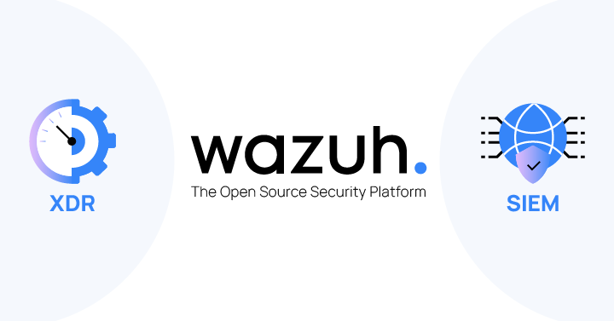

Introduction
The purpose of this project was to set up an Intrusion Detection System (IDS) computer using VM Ware. I imported a pre-built Wazuh server as an OVA file into VMware Workstation, which saved me time compared to setting it up from scratch. Then, I installed the Wazuh agent on both a Linux Server and a Windows Server. I also tested the setup by using a Kali Linux machine to run a brute-force attack to see if Wazuh would detect it.

1: Setting Up VM Ware and VMs
I created a custom NAT network in VMware so all my virtual machines could communicate internally. This setup made it easier to manage IP addresses, since VMware assigned them automatically. Even though the VMs could not be accessed from outside the host computer, they could talk to each other, which was enough for this project.
I added the following VMs to the same NAT network:
- Wazuh Server (imported from an OVA file)
- Linux Server (Ubuntu 22.04)
- Windows Server 2022
- Kali Linux (used to simulate attacks)
I made sure the Wazuh server had a static IP inside the NAT range, so the agents could connect to it without the IP changing on reboot.

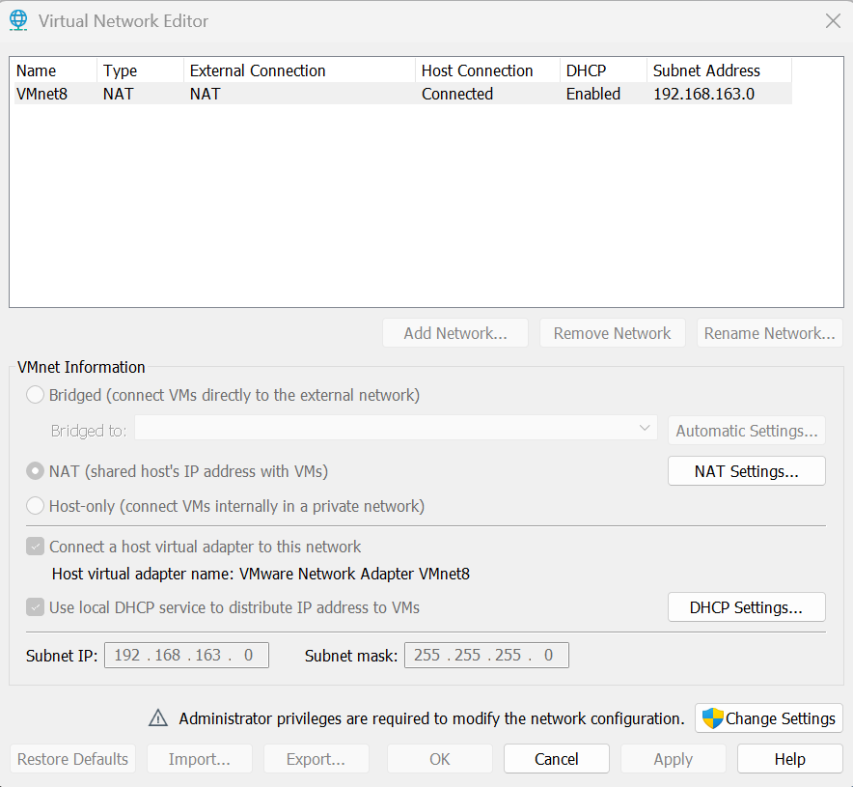
Screenshot Showing NAT Network Settings in VMWare Workstation

2: Importing the Wazuh OVA in VMware
I downloaded the Wazuh OVA file and imported it into VMware Workstation.
After starting it, I:
- Logged into the terminal and ran ip a to find its IP address
- Used that IP to access the Wazuh web dashboard in my browser:
https://192.168.163.137
- Logged in using the default username and password
This OVA already had the Wazuh Manager set up. I didn’t need to install anything manually, which saved time.

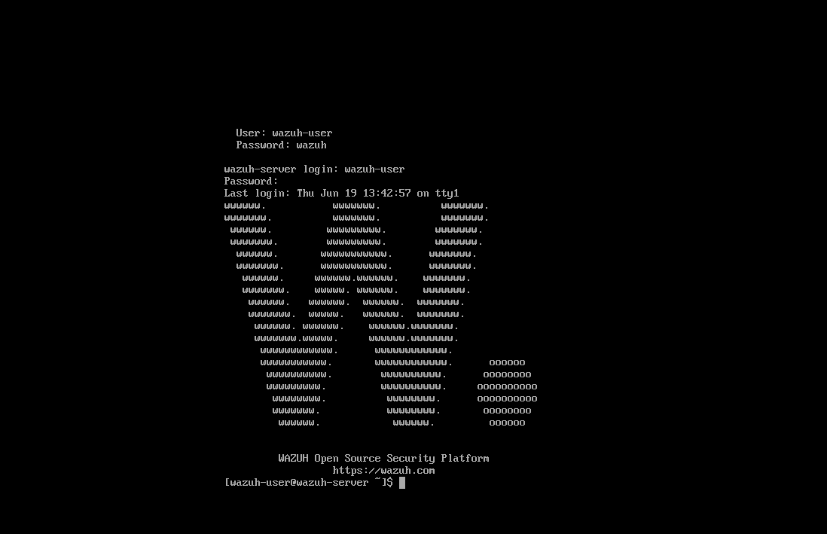
Screenshot Showing Wazuh OVA in VM Ware

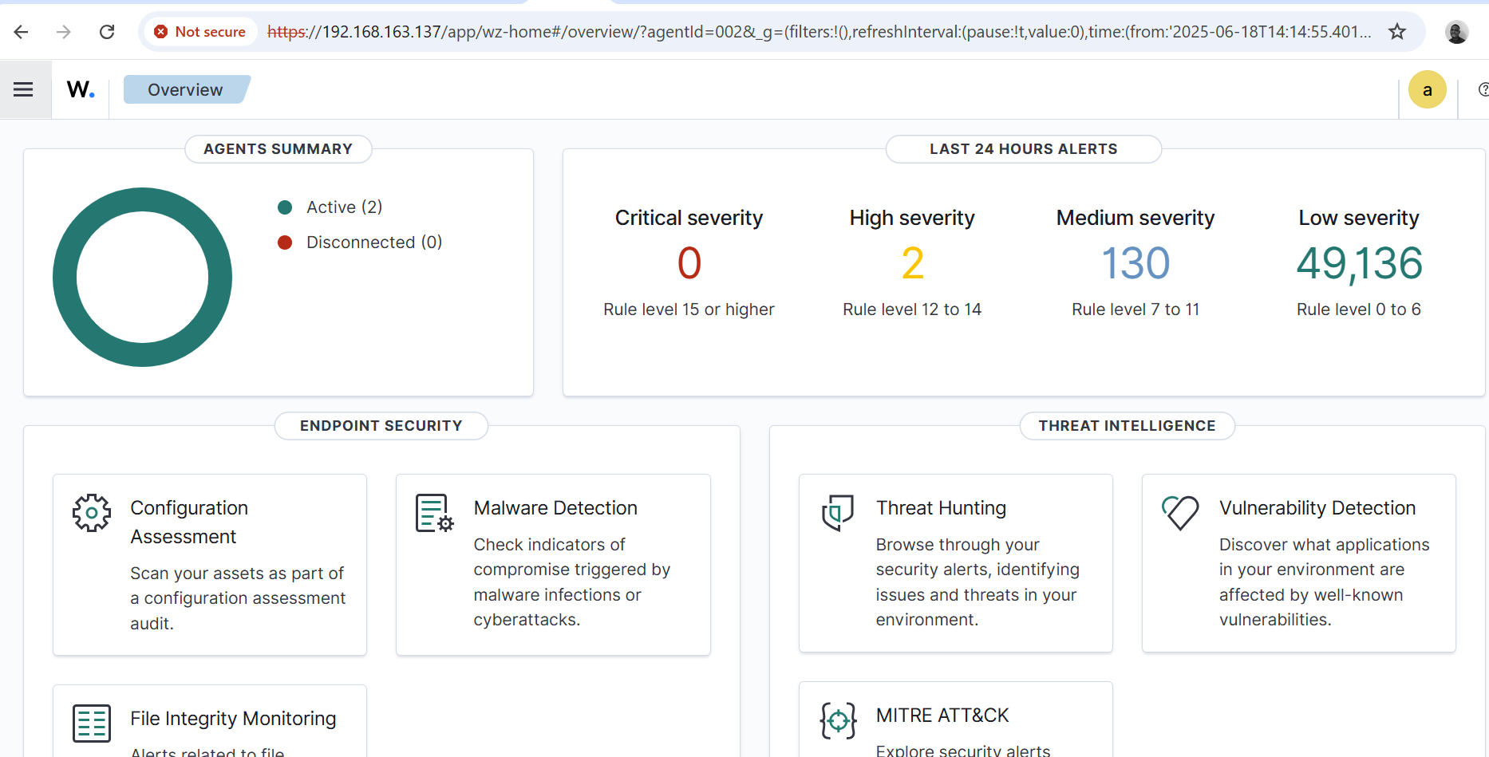
Screenshot of the Wazuh Dashboard
3. Installing the Linux Agent
On my Linux Server, I installed the Wazuh agent using the install new Wazuh agent command curl -s https://packages.wazuh.com/install.sh | sudo bash.
After that, I went to the Wazuh dashboard, navigated to Agents → Add Agent, entered the Linux VM’s name and IP address, and copied the generated registration key. Back on the Linux Server, I opened the agent manager by running:
sudo /var/ossec/bin/manage_agents
I pasted the registration key, saved it, and then restarted the agent using:
sudo systemctl restart wazuh-agent
Shortly after, the Linux agent appeared as Active in the Wazuh dashboard, confirming it was successfully connected.

4. Installing the Windows Agent
On my Windows Server VM, I downloaded and installed the Wazuh agent file. During the installation, I entered the Wazuh server’s IP address), and typed in the agent’s name. After the installation finished, I opened the Wazuh Agent Manager, went to the “Manage Keys” section, and pasted the registration key that I had copied earlier from the Wazuh dashboard. I saved the changes and started the agent service. Once everything was up and running, the Windows VM appeared as an active agent in the Wazuh dashboard.
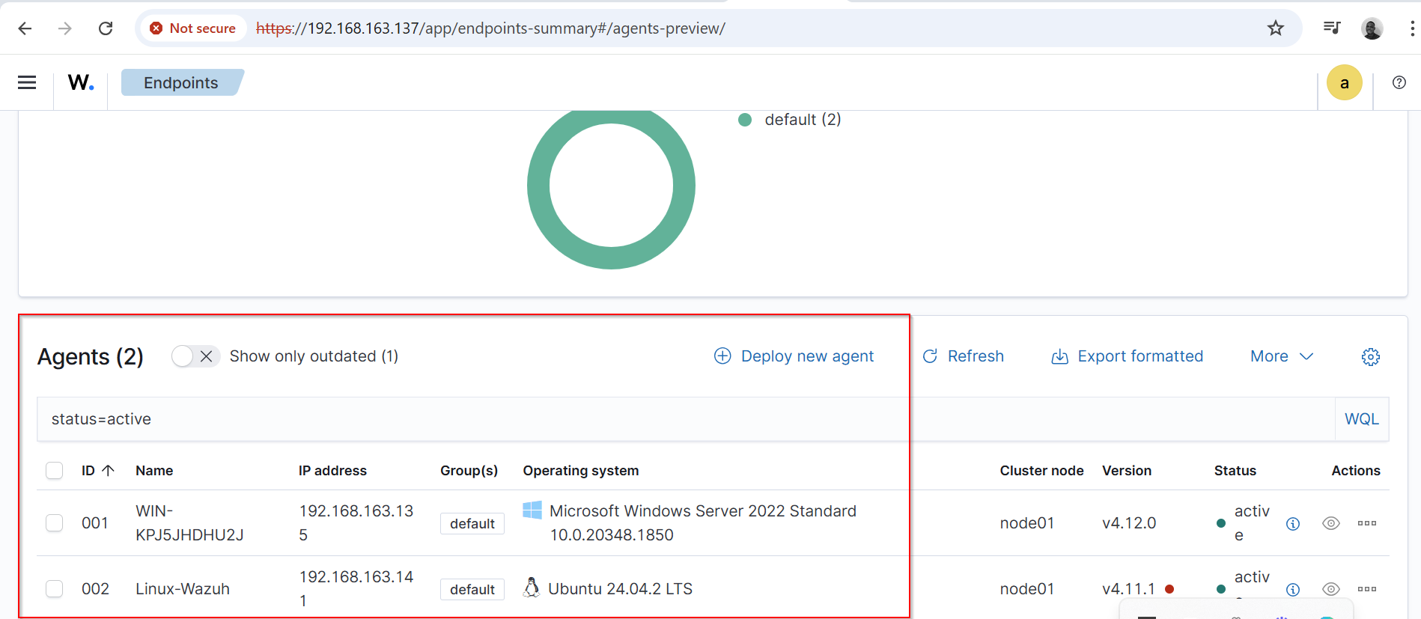
Screenshot Showing Windows Server and Linux Sever are Active on the Wazuh Dashboard
5. Making Sure Everything Could Connect (NAT Setup Check)
Since all VMs were on the same NAT network, they could talk to each other using their local NAT IPs. I used ping and telnet to test communication: No additional port forwarding or firewall changes were needed because the network was fully internal to VMware.

6. Enabling Remote Desktop and SSH on Windows and Linux Server
On my Windows Server VM, I first enabled Remote Desktop so it could be targeted for testing. I did this by going to System Properties → Remote settings, then selecting “Allow remote connections to this computer”. I also made sure the firewall allowed RDP (port 3389) by checking Windows Defender Firewall with Advanced Security.
On my Linux Server, I made sure SSH was enabled so it could also be attacked and monitored. I installed and started the SSH service with the following commands:
sudo apt update
sudo apt install openssh-server
sudo systemctl enable ssh
sudo systemctl start ssh

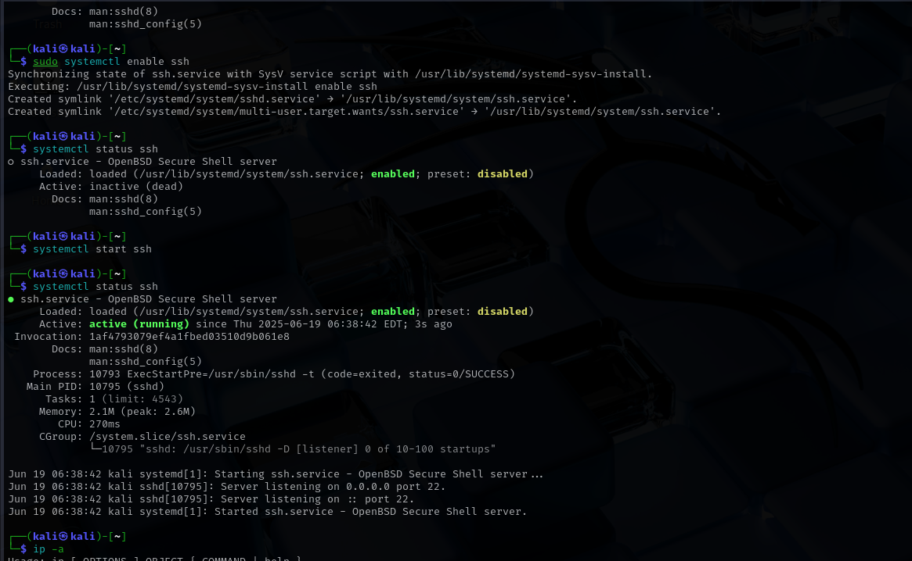
Screenshot of SSH Enabled on Kali Linux

7. Simulating an Attack with Kali Linux
To test whether Wazuh could detect attack activity, I used Hydra on my Kali Linux VM to perform brute-force login attempts against both the Linux server and the Windows Server VMs.
Before launching the attacks, I created two simple wordlist files on Kali:
usernames.txt – containing test usernames
passwords.txt – containing sample passwords
I also created a test user account on the Windows Server by opening Computer Management → Local Users and Groups → Users, then adding a user called “testuser” with a known password for testing purposes.
Once everything was ready, I started the attacks from Kali by brute forcing the Linux Server using the command;
“hydra -L usernames.txt -P passwords.txt ssh://192.168.163.141”.
This attack ran successfully. Shortly afterward, I checked the Wazuh dashboard and found several alerts under the Security Events tab. Wazuh flagged the repeated failed SSH login attempts.
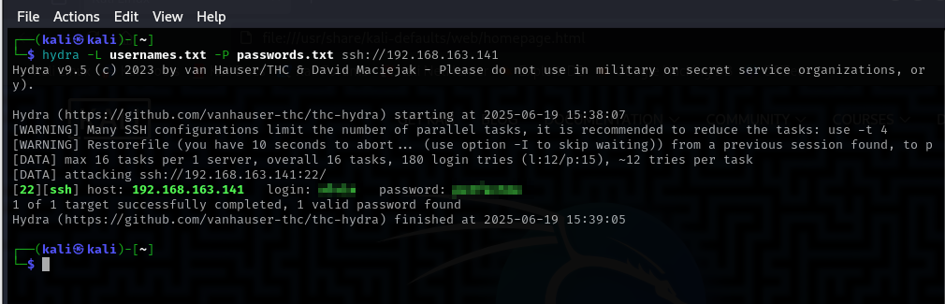
Screenshot Showing Successful Brut Force Against the Linux VM
This confirmed that the Linux agent was working properly and forwarding logs to the Wazuh server as expected.
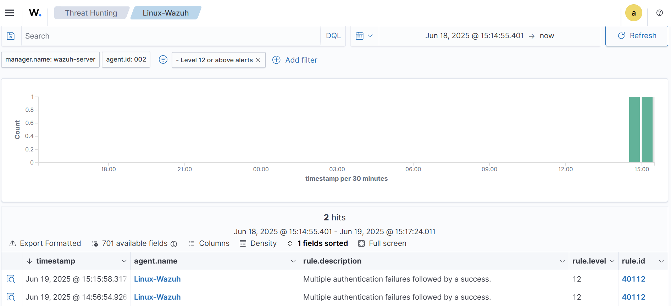
Screenshot Showing Security Events of the Linux Server

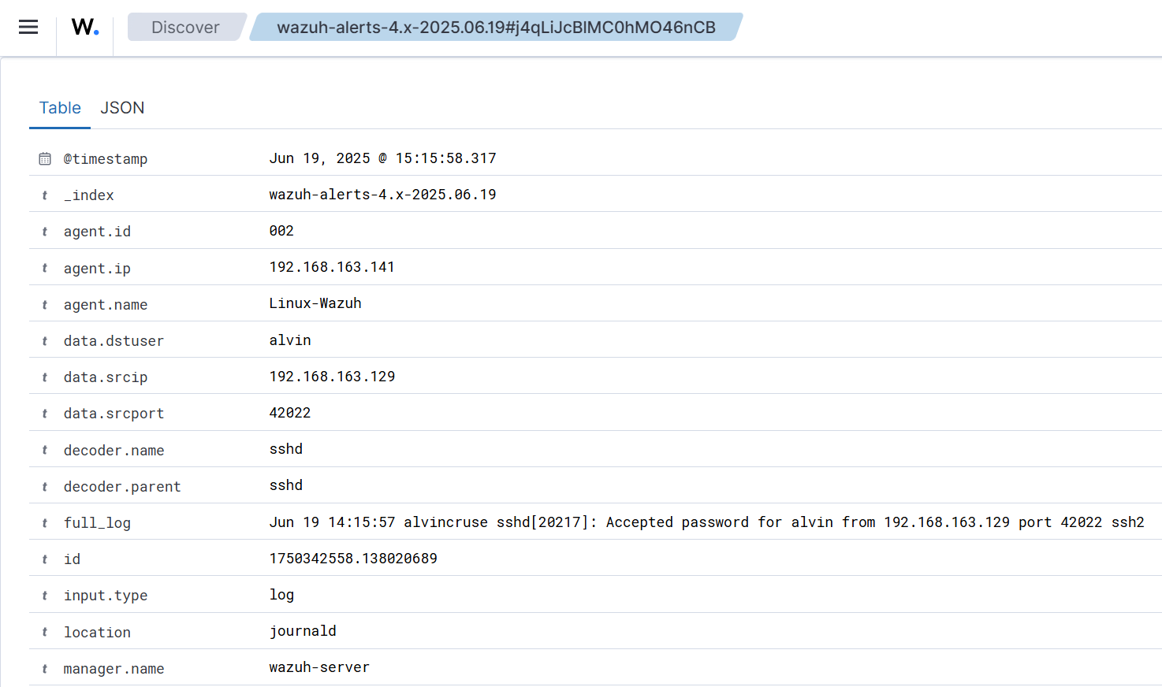
Screenshot Showing Sample Alert Details of the Linux Server

In trying to attack the Windows Server, I employed RDP brute-force attack against the Windows Server using the command;
“hydra -t 4 -L usernames.txt -P passwords.txt rdp://192.168.163.135”.
Although Hydra appeared to run without errors, I was not able to see any corresponding logs or alerts in the Wazuh dashboard from the Windows VM. It seemed like the Windows agent was not capturing or forwarding the RDP login attempts, or the RDP activity was not being logged in a way Wazuh could detect. I verified that the agent was listed as Active in the dashboard, but no brute-force logs appeared from the Windows side.
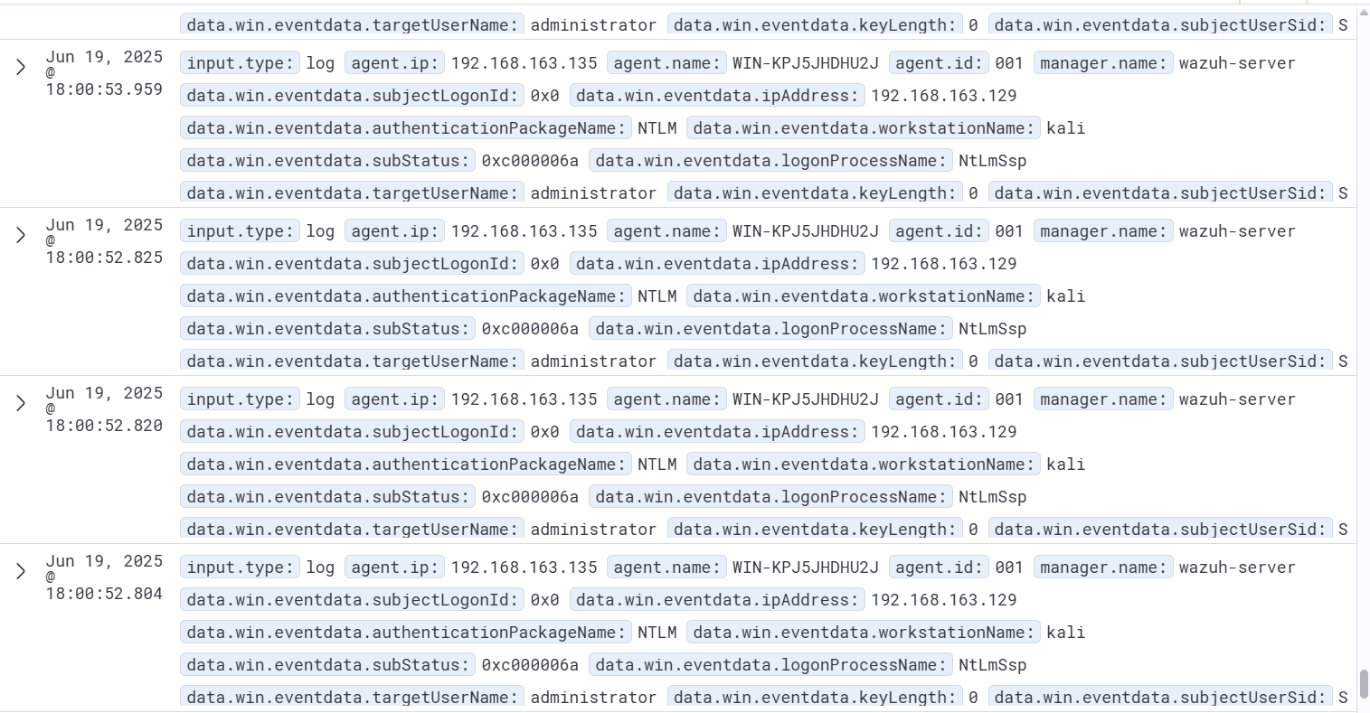
Screenshot Showing Sample of Security Events of the Windows Server
This showed that while the Linux detection worked correctly, I would need to further troubleshoot or adjust the Windows logging settings (such as enabling detailed RDP audit logs or checking firewall and agent configurations) to capture RDP attacks successfully in the future.

8. Lessons Learned
Throughout this project, I gained valuable hands-on experience with HIDS deployment and configuration. Here are the key lessons I learned:
- NAT networking is useful for lab setups and keeps everything isolated.
- The OVA made setting up Wazuh simple as there was no need for manual installation.
- Agent registration requires copying keys and restarting the service.
- Wazuh can detect real-time attacks and provide detailed logs.
- It’s important to test networking first before installing agents.

Conclusion
This project helped me understand how to build and test an IDS using Wazuh. By using NAT networking in VMware, I was able to keep all machines connected securely within a private subnet. I learned how to register agents on Linux and Windows, and how to simulate attacks using Kali. Most importantly, I saw how Wazuh detects threats and how useful it is in monitoring systems in real time.

